Year 6 Summer 1 PSHCE – Puberty,Relationships and Reproduction(RSE)
Key facts  - We will all go through puberty.  - Puberty is an important part in the human life cycle.  - During puberty, our bodies and feelings go through changes.  - Going through puberty will allow most people to reproduce, if they choose to.  - During a period, girls/women can feel physical pain and discomfort as well as tense or moody.  - Once a young person reaches puberty, they produce more sweat.  - If the sweat isn’t washed away, it can turn into body odour.  - People do not always tell the truth online.  - In healthy relationships, both people are happy and enjoy spending time with each other.  - In healthy relationships, both people respect each other’s wishes. | 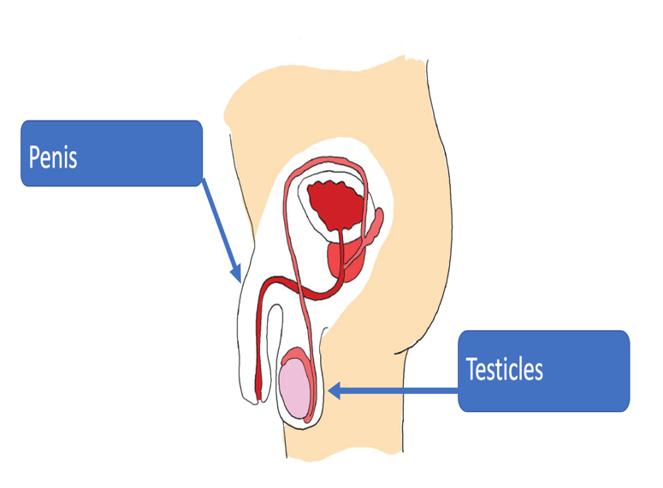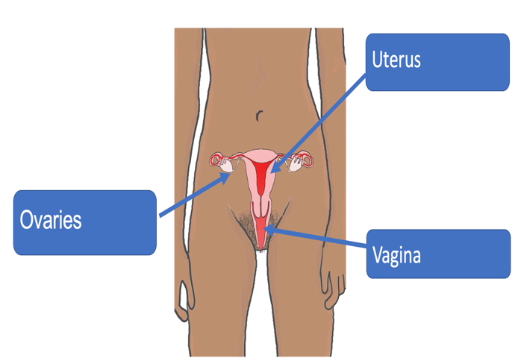
 | Vocabulary  - puberty  - womb  - sperm  - egg  - conception  - fertilisation  - pregnancy  - sexual intercourse  - twins  - fostering  - adoption  - relationship  - friendship  - love  - consent  - intimacy  - communication  - private information  - internet safety | 