Year 6 Spring 2 – Binary
Key Images | Key Learning
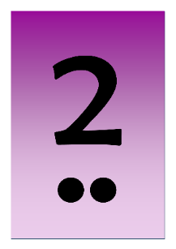  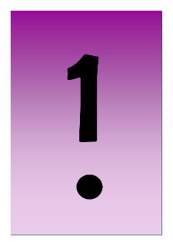  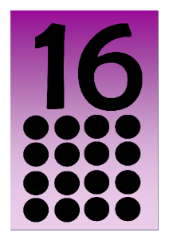  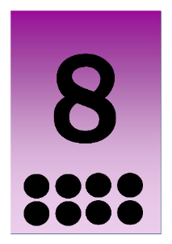  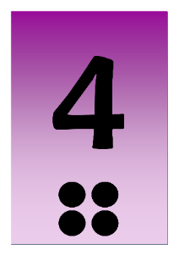 | - To know what the terms binary and denary mean and how they relate to the number system, the digital system and the terms base-10 and base-2  - To relate binary to the on and off states of electrical switches.  - To convert numbers from decimal to binary.  - To convert numbers from binary to decimal.  - To represent states of object in their own program using binary.
 | Key Vocabulary | Key Questions
 | - Base 10  - Base 2  - Binary  - Bit  - Byte  - Decimal  - Denary  - Digit  - Gigabyte (GB)  - Integer  - Kilobyte (KB).  - Machine code  - Megabyte (MB).  - Nibble  - Switch  - Tetrabyte (TB)  - Variable | How does binary relate to the programs that you use or create?  In a computer everything is translated into binary stored by on and off switches that pass electronic signals that the computer interprets. It can then pass the correct signals to the components of the computer such as the sound card to make the requested sound. Or graphics card to make images appear on the screen.  How does binary relate to computer memory.  A single 0 or 1 is called a bit. The word comes from Binary Digit.  The bigger the program, the more bits are used so more memory space is taken up. For example, 1 byte is 8 bits, 1 megabyte (Mb) or 8,388,608 bits, 1 gigabyte (GB) is 8,589,934,592 bits!  How would you write the numbers 0 to 10 in binary?  0, 1, 10, 11, 100,101,110,111,1000, 1001, 1010.
Reference to

