Year 6 Spring 2 PSHCE –Democracy and Decisions
Key facts  - Lots of things that affect our lives, such as schools, hospitals and the environment, are discussed in Parliament.  - The Houses of Parliament, also known as the Palace of Westminster, is in the centre of London.  - Parliament is made up of three parts: the House of Commons, the House of Lords and the king or queen – known as the Monarch.  - The House of Commons is made up of Members of Parliament (MPs). MPs are elected to represent our views in the House of Commons.  - Every 5 years, a general election is called by the Prime Minister.  - The Government is led by the Prime Minister.  - The Prime Minister belongs to the political party with the majority of the seats. | 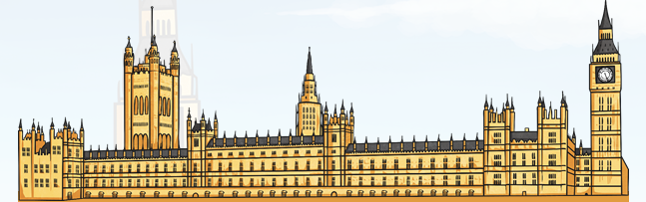  Parliament  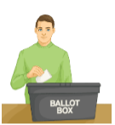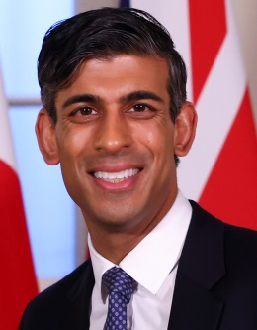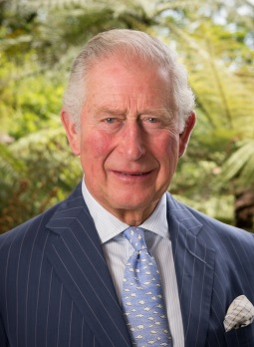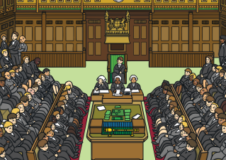  elections Prime Minister King Charles I House of Commons
 | Vocabulary  Parilament  House of Commons  House of Lords  Westiminster  Prime Minister  polcitical party  Memebers of Parliament  government  Monarch | 