Year 6 Spring 1 PSHCE –Discrimination
Key information  - Ageism is when you discriminate against someone because of their age.  - Sexism is discriminating against someone because of their gender.  - Racism is discriminating again someone because of their race.  - Disability discrimination is discriminating against someone because of a disability they may have.  - Stereotyping is a generalised and simplistic idea of a group of people which is usually negative.  - Prejudice is believing some people are inferior or superior without even knowing them.  - Discrimination is to act on the basis of prejudice. | 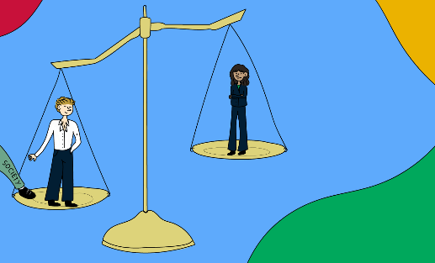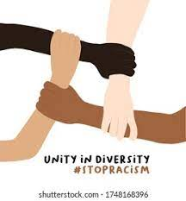  Sexism  Racism  Ageism  Stereotypes
 | Vocabulary  - ageism  - sexism  - racism  - disability  - stereotype  - prejudice  - discrimination  - superior  - diversity  - equality | 