Year 6 Autumn 2 – Coding
Key Images | Key Learning
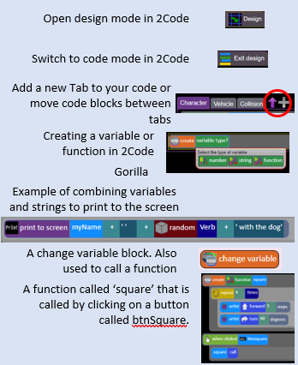 | - To use the program design process, including flowcharts, to develop algorithms for more complex programs using and understanding abstraction and decomposition to define the important aspects of the program.  - To code, test and debug from these designs.  - To use functions and tabs in 2Code to improve the quality of the code.  - To code user interactivity using input functions.
 | Key Vocabulary | Key Questions
 | - Action  - Alert  - Algorithm  - Bug  - Code Design  - Command  - Control  - Debug/Debugging  - Event  - Function  - If  - If/Else  - Input  - Output  - Object  - Repeat  - Sequence  - Selection  - Simulation  - Tabs  - Timer  - Variable | How can you use Tabs in 2Code Gorilla?  Tabs are used to organise your code and make it more readable. This also makes it easier to debug. Give the Tabs useful names to help with this.  What is a function in coding? Give an example that you have used in 2Code Gorilla.  A function is a block of code that you can access when you need it, so you don’t have to rewrite the same block repeatedly. You call the function each time you want it. In a turtle program you could have a button that will make the turtle draw a square each time you click it. In the text adventure, there were functions for each room that were called when the user navigated to the room.  In 2Code Gorilla, how can a program receive user input?  When the user clicks on an object, when the user presses keys or swipes the screen with the mouse, the ‘Get Input’ and ‘Prompt for input’ commands.  On a touchscreen: when the screen is touched or swiped.
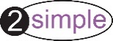
Reference to

