Year 6 Autumn 2 PSHCE – Anti-bullying
Key information  - Bullying is purposely hurting someone else.  - Bullying is REPETITIVE – which means it happens again and again. It is not the same as something happening once.  - Bullying can be physical, verbal or mental. It hurts the victim a lot and in many different ways.  - Physical bullying (like hitting or kicking) and verbal abuse (like calling names or making fun of someone) are often more obvious to see.  - Cyber bullying happens online .  - If you are being bullied or know some being bullied, tell someone you trust – a parent, teacher, older relative. | 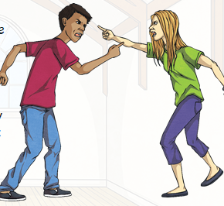  Cyber bullying  Conflict  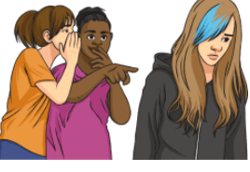  Bullying (if it is repetitive)
 | Vocabulary  - conflict  - resolutions  - cyber bullying  - anti-bullying  - prejudice  - racism  - support  - emotions | 