Year 6 Autumn 1b – Networks
Key Images | Key Learning
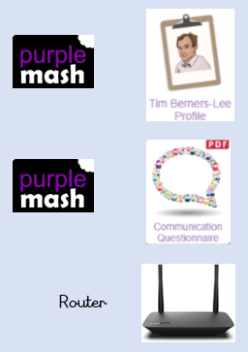  Router | - To learn about what the Internet consists of.  - To find out what a LAN and a WAN are.  - To find out how the Internet is accessed in school.  - To research and find out about the age of the Internet.  - To think about what the future might hold.
 | Key Vocabulary | Key Questions
 | - Internet  - World Wide Web  - Network  - Local area network (LAN)  - Wide area network (WAN)  - Router  - Network cables  - Wireless | What is the difference between the Internet and the World Wide Web?  The Internet is a global network of networks while the Web, also referred formally as the World Wide Web (www) is collection of information which is accessed via the Internet.  What is the difference between a LAN and a WAN?  Both are networks that connect computers together. A LAN (Local Area Network) is normally for computers connected less than 1KM I distance whilst a WAN (Wide Area Network) refers to computers connected more than 1KM away.  Who is Tim Berners-Lee?  Tim Berners-Lee is the inventor of the World Wide Web. The WWW is the system that delivers webpages over the internet.
Reference to

