Year 4 Summer 2 PSHCE – Rights and responsibilities
Key facts  - Children under 18 have rights and responsibilities.  - We have the right to be loved, cared for and protected from exploitation, abuse and violence.  - We have the right to a safe place to live and play and the things we need to be healthy, like clothes, safe water and healthy food.  - We have the right to learn, to express ourselves and access to information and opportunities.  - Not everything on social media is true or real.  - We can all help to stop cyberbullying by being safe and kind online. | 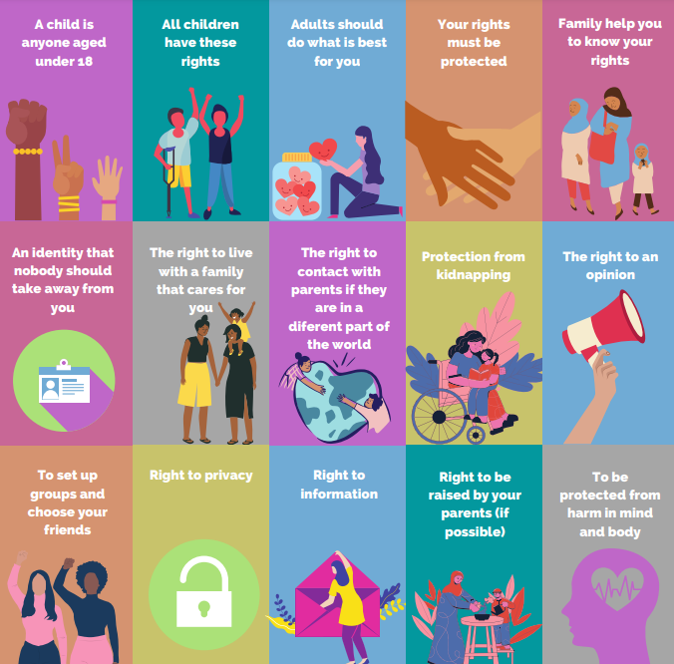
 | Vocabulary  - rights,  - children’s rights,  - social media,  - responsibilities  - cyberbullying  - emotions | 