Year 5 Summer 1 PSHCE – Puberty(RSE)
Key facts  - We will all go through puberty.  - Puberty is an important part in the human life cycle.  - During puberty, our bodies and feelings go through changes.  - Going through puberty will allow most people to reproduce if they choose to.  - During a period, girls/women can feel physical pain and discomfort as well as tense or moody.  - Once a young person reaches puberty, they produce more sweat.  - If the sweat isn’t washed away, it can turn into body odour. | 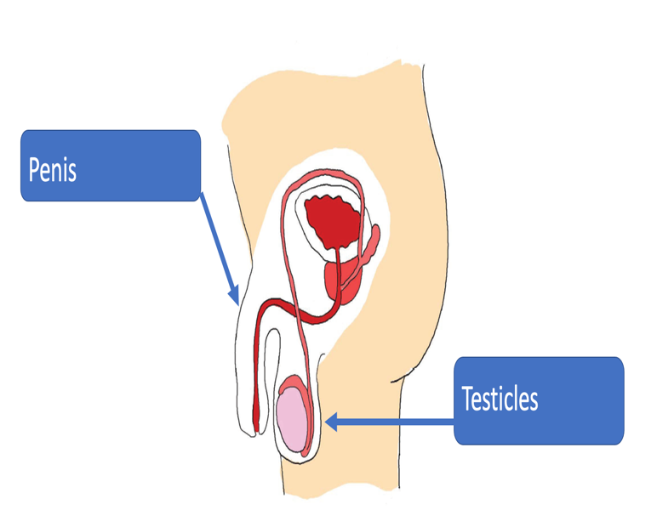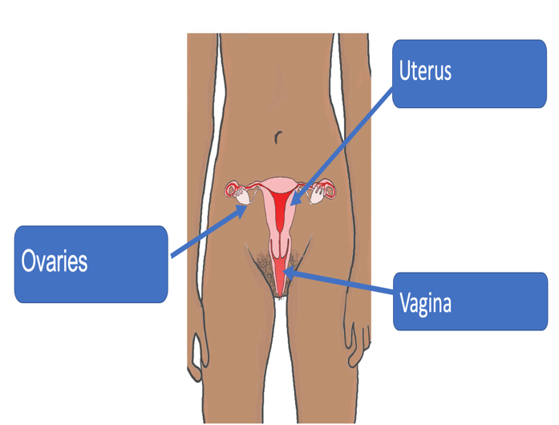
Vocabulary
- puberty
- physical changes
- emotional changes
- moods
- menstruation
- periods
- tampons
- sanitary towels
- wet dreams
- semen
- erection
- sweat
- spots
- pubic hair
- facial hair
- underarm hair
- sexual feelings

