Year 4 Spring 2 PSHCE – Anti-bullying
Key information  Bullying is purposefully hurting someone else.  Bullying is REPETITIVE – which means it happens again and again. It is not the same as something happening once.  Bullying can be physical, verbal or mental. It hurts the victim a lot and in many different ways.  Physical bullying (like hitting or kicking) and verbal abuse (like calling names or making fun of someone) are often more obvious to see.  Cyber bullying happens online.  If you are being bullied or know some being bullied, tell someone you trust – a parent, teacher, older relative. | 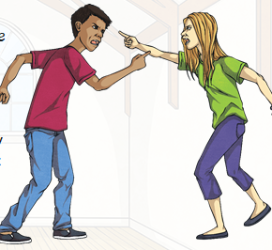  Cyber bullying  Conflict  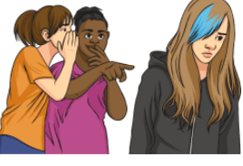  Bullying (if it is repetitive)
 | Vocabulary  - conflict  - resolutions  - cyber bullying  - anti-bullying  - prejudice  - racism  - support  - emotions  - respect | 