Year 5 Spring 1 – Spreadsheets
Key Images | Key Learning
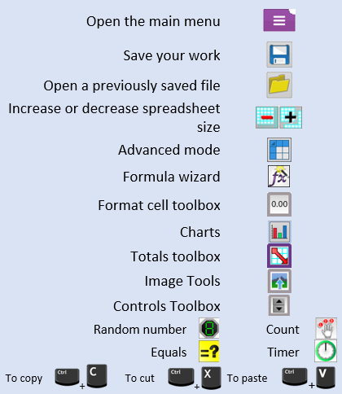 | - Using the formula wizard to add a formula to a cell to automatically make a calculation in that cell.  - To copy and paste within 2Calculate.  - Using 2Calculate tools to test a hypothesis.  - To add a formula to a cell to automatically make a calculation in that cell.  - Using a spreadsheet to model a real-life situation and answer questions.
 | Key Vocabulary | Key Questions
 | - Average  - Advance Mode  - Copy and Paste  - Columns  - Cells  - Charts  - Equals Tool  - Formula  - Formula Wizard  - Move Cell Tool  - Random Tool  - Rows  - Spin Tool  - Spreadsheet  - Timer | How would you add a formula so that the cell shows the product of two other cells?  Click on the cell where you want the product to be displayed then click the formula wizard button. Click on the cell that contains the first number. Choose the x operation then click on the second number. Click OK.  What would you use in 2Calculate to have a cell that automatically calculates the number of days since a certain date?  You could use formulae and the totalling tools. To make the spreadsheet easier to understand, you could use named variables.  Explain what a spreadsheet model of a real-life situation is and what it can be used for?  It represents the data of a situation, for example budgeting for a party, working out how big a field needs to be for a certain number of animals, working out how to spend your pocket money over time, or using the existing data to predict what time your shadow will be a certain length etc.
Reference to

