Year 5 Autumn 2 – Coding
Key Images | Key Learning
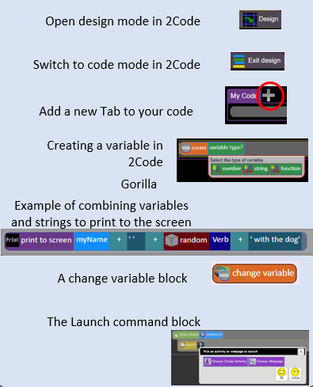 | - To represent a program design and algorithm.  - To create a program that simulates a physical system using decomposition.  - To explore string and text variable types so that the most appropriate can be used in programs.  - To use the Launch command in 2Code Gorilla  - To program a playable game with timers and scorepad.
 | Key Vocabulary | Key Questions
 | - Action  - Alert  - Algorithm  - Bug  - Code Design  - Command  - Control  - Debug/Debugging  - Design Mode  - Event  - Get Input  - If  - If/Else  - Input  - Output  - Object  - Repeat  - Sequence  - Selection  - Simulation  - Timer  - Variable | What does simulating a physical system mean?  Creating a program where the objects behave as they would in the real world. For example, a football program that uses angles, speed and friction to simulate kicking a football. When simulating a physical system, you first must break the system down into parts that can be coded (decomposition). The different parts will come together to make the full simulation.  Describe how you would use variables to make a timer countdown and a scorepad for a game.  Timer countdown: Create a timer variable and set it to the starting number of seconds. Add a Timer command that repeats and subtracts 1 every second. Add a text object in design view to display this number.  Score: create a variable to store the score, each time the user gains a point, change and display the value of the variable.  Give examples of how you could use the Launch command in 2Code.  Clicking on a button or other object in the program to open another 2Code program or a webpage.
Reference to

