Year 4 Autumn 2 PSHCE – Healthy Eating
Key information  - There are many ways for us to stay healthy.  - Eating a varied diet and regular exercise help to keep us healthy.  - We should aim to eat 5 portions of fruit and vegetables a day.  - Foods are not ‘healthy’ or ‘unhealthy’ by themselves, but eating a limited diet can make us unhealthy.  - We need more of some foods than others and should limit some foods such as sugars and fats to help our bodies and teeth stay healthy. | 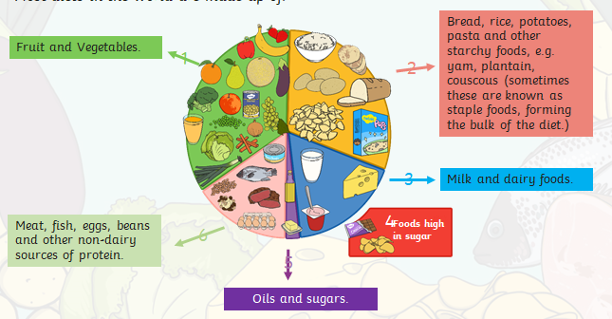
Vocabulary
- protein
- dairy
- choices
- fruit
- vegetables

