Year 4 Summer 1a – Effective Searching
Key Images | Key Learning
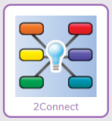 | - To locate information on the search results page.  - To use search effectively to find out information.  - To assess whether an information source is true and reliable.
 | Key Vocabulary | Key Questions
 | - Internet  - Internet browser  - Search  - Search engine.  - Spoof website  - Website  - Easter egg | What is a search engine?  A search engine is a piece of software that allows the user to find and then display pages from the World Wide Web.
Reference to

