Year 4 Summer 1 PSHCE – Growing Up(RSE)
Key facts  - We will all go through puberty.  - Puberty is an important part in the human life cycle.  - During puberty, our bodies and feelings go through changes.  - Going through puberty will allow most people to reproduce, if they choose to.  - Respect is an important part of relationships.  - In healthy friendships, both people are happy and enjoy spending time together. | 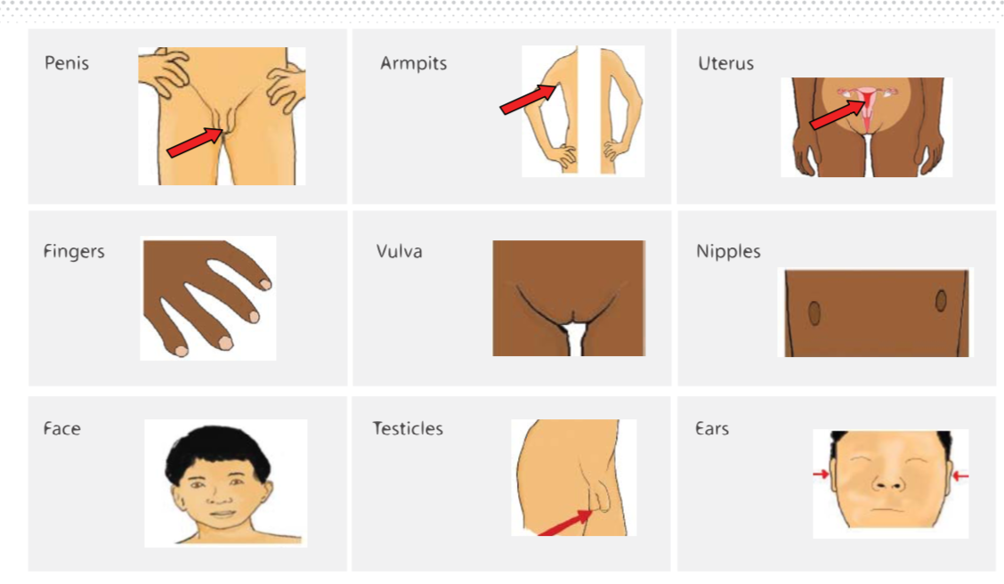
Vocabulary
- puberty
- lifecycle
- reproduction
- physical
- breasts
- sperm
- egg
- pubic hair
- emotional
- feelings
- relationships
- friendships

