Year 4 Spring 2 – Writing for Different Audiences
Key Images | Key Learning
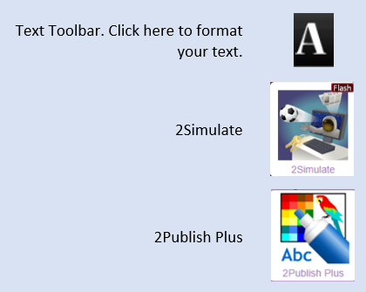 | - To explore how font size and style can affect the impact of a text.  - To use a simulated scenario to produce a news report.  - To use a simulated scenario to write for a community campaign.
 | Key Vocabulary | Key Questions
 | - Font  - Bold  - Italic  - Underline | Why should I change the font when I am writing?  Changing the appearance of the font can help make things easier to read and highlight important parts of the text.
Reference to

