Year 4 Spring 1 PSHCE –Persuaion and Pressure
- Key facts  - Peer Pressure is when a person or group of people, who are your peers, try to convince you to behave or act in a certain way.  - Your peers are the people who are similar in age or background to you.  - Positive peer pressure is when a peer, or a group of your peers, try to convince you to do the right thing or something good/helpfulbuy something that you want.  - Negative peer pressure is when a peer, or a group of your peers, try to convince you to do the wrong thing or something bad/hurtful | 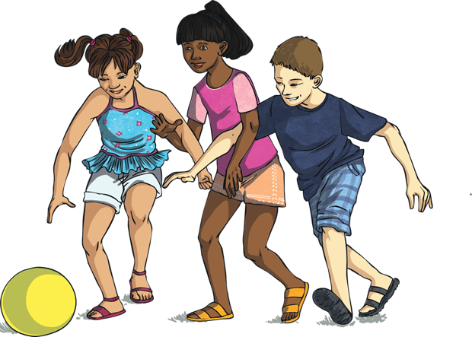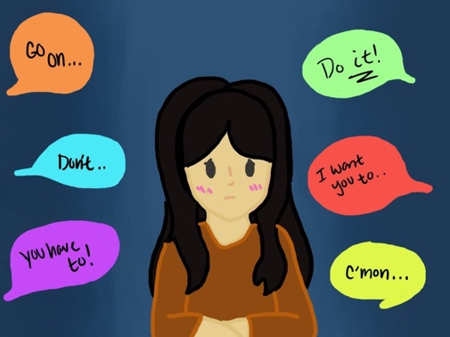  peers  Peer pressure
 | Vocabulary  peer pressure  attitude  negative  influence  choices  positive | 