Year 4 Autumn 2 – Coding
Key Images | Key Learning
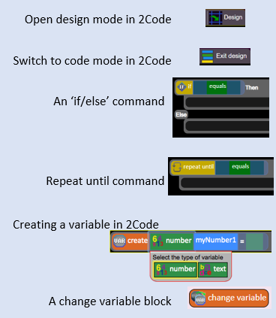 | - To use selection in coding with the ‘if/else’ command.  - To understand and use variables in 2Code.  - To use flowcharts for design of algorithms including selection.  - To use the ‘repeat until’ with variables to determine the repeat.  - To learn about and use computational thinking terms decomposition and abstraction.
 | Key Vocabulary | Key Questions
 | - Action  - Alert  - Algorithm  - Bug  - Code Design  - Command  - Control  - Debug/Debugging  - Design Mode  - Event  - Get Input  - If  - If/Else  - Input  - Output  - Object  - Repeat  - Selection  - Simulation  - Timer  - Variable | Explain the stages of the design, code, test, debug coding process.  This is a process to go through as you create a program using coding  - Design: Create a design which could be a flowchart, a labelled diagram or a storyboard. This helps to think through the algorithms required  - Code: code the algorithms usbng9in and adapting the design.  - Test and Debug: see if the program works and fix any errors.  How can variables and if/else statements be useful when coding programs with selection?  The variable could be set either to 0 or 1 and this could be changed by user action or a timer. If/else statement outcomes could depend upon the value of the variable.  What do the terms decomposition and abstraction mean. Use examples to explain them.  Decomposition is breaking a task into its component parts so that each part can be coded separately.  If you were coding a game of chess, you could decompose into the moves of the different pieces and the setup of the playing space.  Abstraction is removing unnecessary details to get the program functioning. In the example, the colour and size of the squares is not important to game play.
Reference to

