Year 3 Summer 2 PSHCE – Peer Pressure
Key facts  - We are all influenced by our peers and this can be a good thing.  - Peer pressure means wanting to do something to fit in with others.  - Positive peer pressure might mean encouraging us to try harder in school, start a new sport or like new music.  - Negative peer pressure might make us feel like we have to do something hurtful or unsafe to be liked.  - It is important to stand up for ourselves and say “no” to anything we know is wrong or unsafe. | smoking  peer pressure  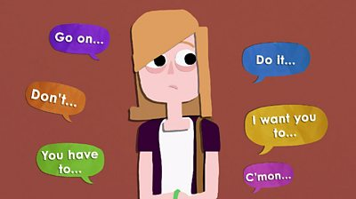
 | Vocabulary  - peer pressure  - positive  - negative  - smoking  - cigarettes | 