Year 3 Summer 1b – Spreadsheets
Key Images | Key Learning
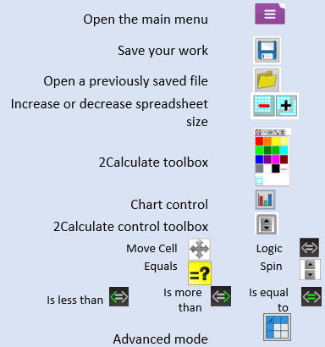 | - To use the symbols more than, less than and equal to, to compare values.  - To use 2Calculate to collect data and produce a variety of graphs.  - To use the advanced mode of 2Calculate to learn about cell references.
 | Key Vocabulary | Key Questions
 | - a < b means ‘a is less than b’.  - a > b means ‘a is greater than b’.  - a = b means ‘a is equal to b’.  - Advance Mode  - Copy And Paste  - Columns  - Cells  - Delete Key  - Equals Tool  - Move Cell Tool  - Rows  - Spin Tool  - Spreadsheet | Explain how you would collect data to find out children’s favourite school subjects. What sort of graph would you create?  Label one column ‘Subject’ and list the subjects in this column. In the cells to the right put in the number of children who like this subject. Use the chart button to automatically create a chart. A pie chart would be a suitable choice.  How can you make a 3 times table machine using the spin tool? Could you use the equals tool to check your answer?  Put the spin tool in the left most cell of a row. Type 0 x 3 in the next three cells. Put an equals tool in the next cell in the row. When you spin the spin tool, the question will change. Enter the answer and the equals tool will tell you if it is correct.  Explain how you would locate a cell in the advanced mode?  Cells in advanced mode have rows labelled with numbers, and columns labelled with letters. So, each cell has a number and letter. For example, A1 or D7.
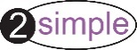
Reference to

