Year 3 Spring 2 PSHCE – Feeling Sad and Making Choices
Key facts  - We all have feelings and emotions.  - It is normal to feel upset or sad sometimes.  - When we feel down, some things may help to cheer us up.  - There are ways to cope with our emotions.  - As we get older, we learn better ways to deal with our emotions, | 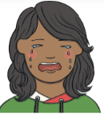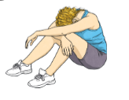  children  happy  upset  sad
 | Vocabulary  - emotions  - feelings  - upset  - happy  - sad  - glad  - cheerful  - unhappy  - overwhelmed | 