Year 3 Spring 1 – Touch Typing
Key Images | Key Learning
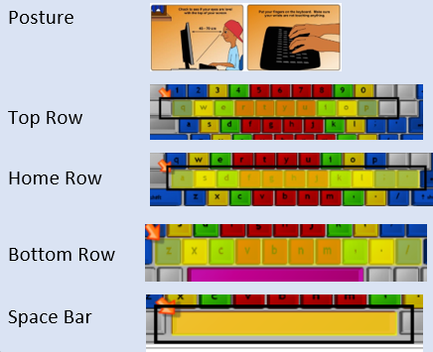 | - To introduce typing terminology.  - To understand the correct way to sit at the keyboard.  - To learn how to use the home, top and bottom row keys.  - To practice typing with the left and right hand.
 | Key Vocabulary | Key Questions
 | - Posture  - Top row keys  - Home row keys  - Bottom row keys  - Space bar | Why should I have a good posture at the computer?  A good posture is important to help you avoid any injuries that come from repeatedly using the computer incorrectly.  Why should I type certain keys with certain fingers?  Using specific fingers for specific keys allows you to type more quickly.
Reference to

