Year 3 Spring 1 PSHCE – Money Choices
Key facts  - A need is necessary for survival and something you can’t live without.  - A want is something you would like to have which would make your life more comfortable or enjoyable.  It is not necessary for survival.  - Saving your money can help you buy something that you want. | 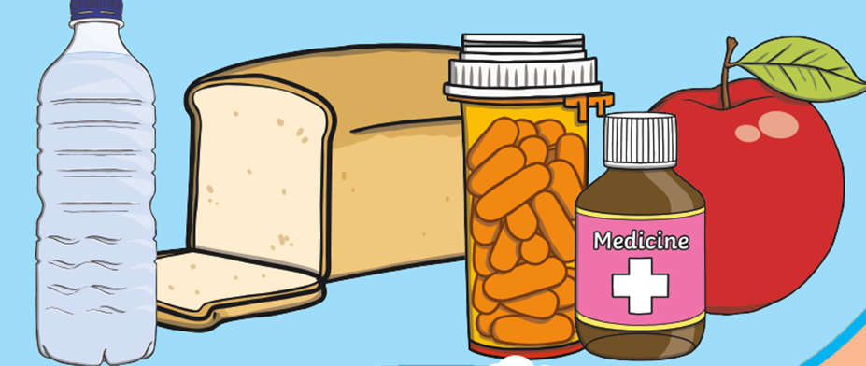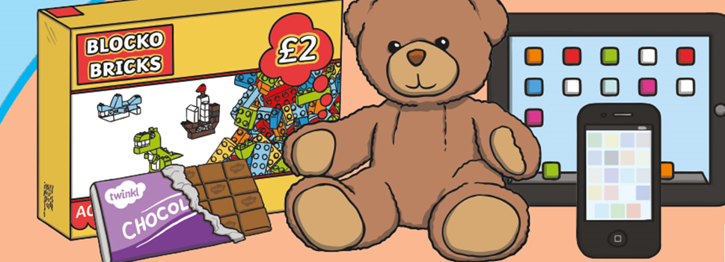  wants  needs  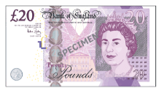  money savings
Vocabulary
money
choices
needs
wants
spend
budget
savings
income

