Year 3 Autumn 2 – Coding
Key Images | Key Learning
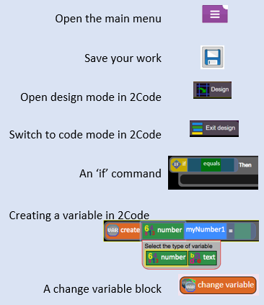 | - To design algorithms using flowcharts.  - To design an algorithm that represents a physical system, and code this representation.  - To use selection in coding with the ‘if’ command.  - To understand and use variables in 2Code.  - To deepen understanding of the difference between timers and repeat commands.
 | Key Vocabulary | Key Questions
 | - Action  - Algorithm  - Bug  - Code Block  - Code Design  - Command  - Control  - Debug/Debugging  - Design Mode  - Event  - If  - Input  - Output  - Object  - Properties  - Repeat  - Computer Simulation  - Selection  - Timer  - Variable | What is the difference between the different object types in 2Code Gibbon level?  The different objects have different properties. This makes then suitable for different type of programs.  - Buttons can only be clicked and have their colour and text changed.  - Vehicles have speed and angle.  - Characters have movement in 4 directions  - Turtles have rotation, pen up and down.  What does selection mean in coding and how can you achieve this in 2Code?  The code will contain commands that require a decision and the next code to run will depend upon the outcome of this decision. In 2Code we used the ‘if’ command for selection.  Give an example of how you could use a variable in coding.  Some examples are:  - A timer that counts every second and displays the value.  - A value that changes depending upon whether a switch is on or off.  - Storing how many times a user has clicked on an object.
Reference to

