Year 2 Summer 1 PSHCE – Differences (RSE)
Key facts  - Boys and girls have different private parts.  - When people use the word FEMALE, they are often talking about girls or women.  - When people use the word MALE, they are often talking about boys or men.  - There are some similarities and differences between males and females.  - Making a new life needs a male and a female. | female  male  baby  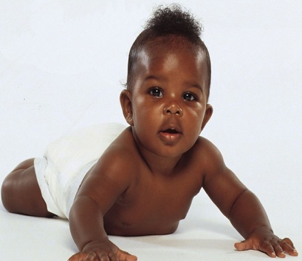
 | Vocabulary  - similar  - different  - sex  - gender  - roles  - stereotypes  - boy  - girl  - male  - female  - private parts  - penis  - vulva | 