Year 1 Spring 2 PSHCE – Growing and Changing

Key facts  - The human life cycle starts with the baby stage.  - Babies cannot look after themselves. They need an adult to help them.  - As we get older, our bodies change.  - As children become older, they can do more things by themselves.  - A teenager is anyone from the age of 13-19 years old. | 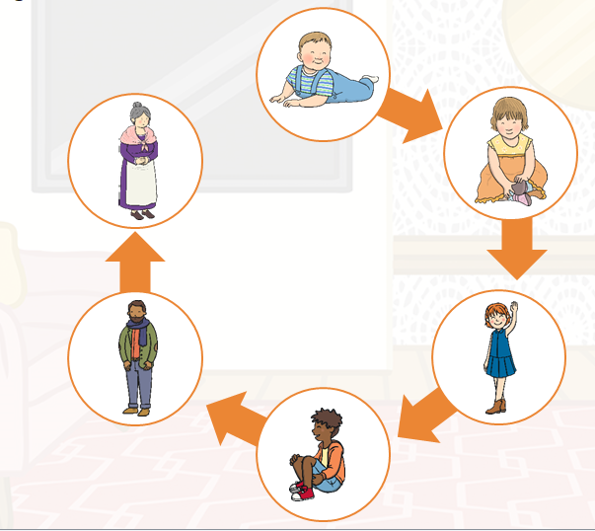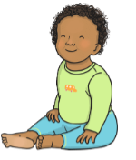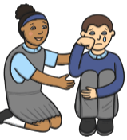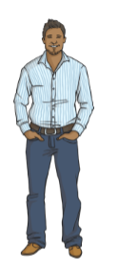  adult  children  children  baby  human life cycle
 | Vocabulary  - growing  - changing  - adult  - toddler  - child  - teenager  - adult  - human life cycle | 