Year 2 Spring 1 – Spreadsheets
Key Images | Key Learning
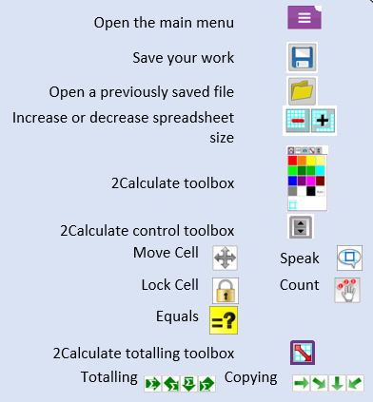 | - To use 2Calculate image, lock, move cell, speak and count tools to make a counting machine.  - To learn how to copy and paste in 2Calculate.  - To use the totalling tools.  - To use a spreadsheet for money calculations.  - To use the 2Calculate equals tool to check calculations.  - To use 2Calculate to collect data and produce a graph.
 | Key Vocabulary | Key Questions
 | - Backspace key  - Copy and paste  - Columns  - Cells  - Count tool  - Delete key  - Equals tool  - Image toolbox  - Lock tool  - Move cell tool  - Rows  - Speak tool  - Spreadsheet | Why would you copy and paste when using a spreadsheet?  You might want to rearrange the information in the spreadsheet.  It will save you entering the same information many times if you want to repeat things in different cells.  How could a spreadsheet help you when you are planning some shopping?  Yes, you could use it to store the process and work out how much it would cost to buy the things that you wanted.  Look at the graph made in 2Calculate showing the class’ favourite pets. Which is the most popular?  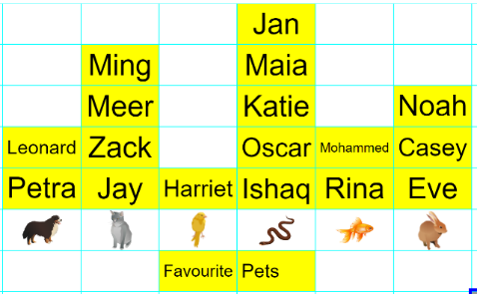
Reference to

