Year 1 Spring 1 PSHCE –Losing and Finding
Key facts  - Sometimes things get lost..  - We might feel upset when we lose something special.  - Sometimes we find things that were once lost.  - Sometimes we might lose something and never find it again. | 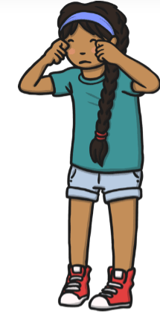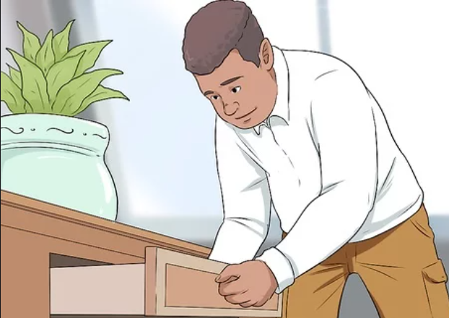
Vocabulary
- lost
- lose
- find
- feeling
- upset’
- emotions
- stress
- search
- lost property

