Year 2 Autumn 2 – Coding
Key Images | Key Learning
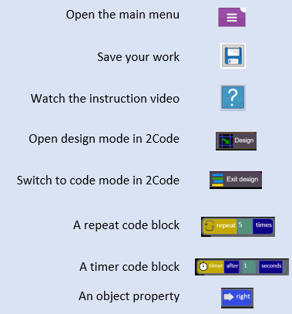 | - To understand what an algorithm is.  - To design algorithms and then code them.  - To compare different object types.  - To use the repeat command.  - To use the timer command.  - To know what debugging is and debug programs.
 | Key Vocabulary | Key Questions
 | - Action  - Algorithm  - Bug  - Character  - Code block  - Code Design  - Command  - Debug/Debugging  - Design Mode  - Input  - Object  - Properties  - Repeat  - Scale  - Timer  - When clicked  - When Key | What is an algorithm? Why is it useful in coding?  An algorithm is a step-by-step set of instructions used to solve a problem or achieve an objective.  A clear algorithm can help you to create code that does what it is supposed to do.  Can you explain what the repeat command and the timer command do?  A repeat command will repeat actions a specified number of times.  A timer will repeat every time the timer fires this could be every 4 seconds or after a certain number of seconds.  If you are good at coding, you don’t need to debug. Is this true?  All coders need to debug to make sure that their program works correctly, and the code does what they intended. As you get better at coding, your programs will get more complex and debugging gets even more important.
Reference to

