Year 1 Autumn 2 PSHCE – Awareness of Feelings
Key facts  - Everybody has feelings.  - Some feelings make us feel good.  - Some feelings make us feel bad.  - It is helpful to talk about your feelings.  - Sometimes we can tell how people are feeling by looking at their face. | 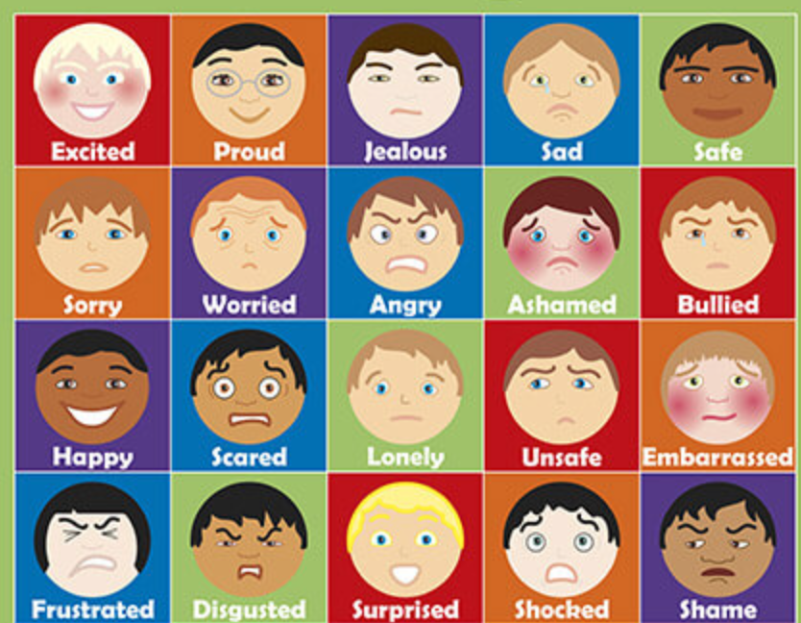
 | Vocabulary  - happy  - lonely  - surprised  - shame  - bullied  - jealous  - worried  - sad  - excited  - proud  - safe  - embarrassed  - scared  - shocked | 