Year 2 Autumn 1 PSHCE – Relationships & Family
Key information  - There are different types of relationships.  - Friends are people not in your family who you like to spend time with.  - Sometimes friends fall out and argue, but good friends always make up.  - Some families look similar to yours.  - Some families look different to yours.  - Families come in all shapes and sizes.  - Love is what makes families the same. | family with one mum and one dad  brother sister  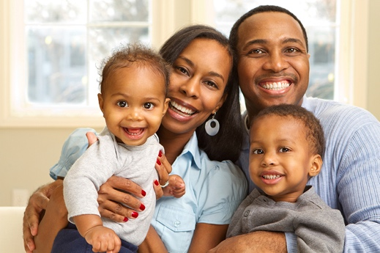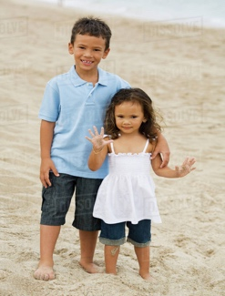  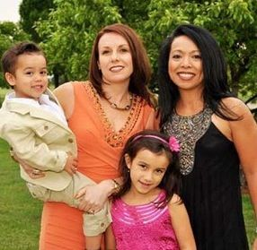  big family  grandparent  family with two dads  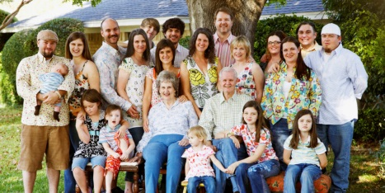  family with two mums
 | Vocabulary  - friend  - fall out  - make up  - family  - siblings  - brother  - sister  - love  - baby  - mum  - dad  - parent  - grandparent  - aunt  - uncle  - cousin | 