Year 1 Summer 2 PSHCE –Road Safety
Key facts  - Vehicles travel on the road and can be dangerous.  - We can look at road signs to help us find a safe place to cross the road.  - A Zebra or Pelican crossing is the safest place to cross the road.  - We can use the “Stop, Look, Listen and Think” sequence to stay safe on the road.  - There are lots of other ways to help us be safe like reflective clothing and holding an adult’s hand. | 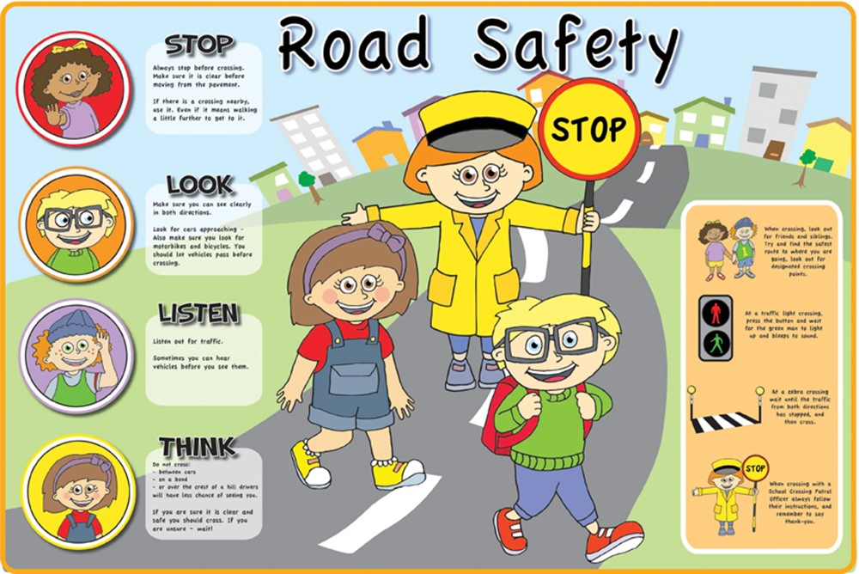
 | Vocabulary  - zebra crossing,  - traffic lights,  - crossing,  - pelican crossing  - vehicle  - road  - pavement  - stop, look, listen, think.  - dangerous  - safe | 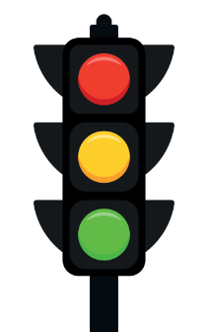  Road crossings  