Year 1 Summer 1 PSHCE – Growing & Caring For Ourselves (RSE)
Key facts  - We are all different but can still be friends.  - As children get older, we grow and change.  - Babies need to be looked after properly. They need care and help.  - As children get older, we can do more things by ourselves.  - Not all families look like ours but that is okay.  - It important to ask a trusted adult for help when we need it. | baby  teenagers Gers  friends  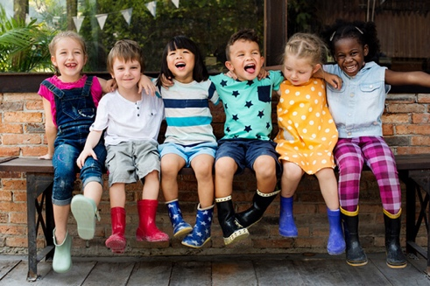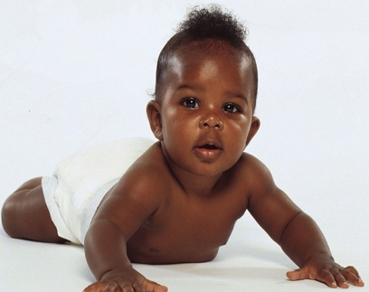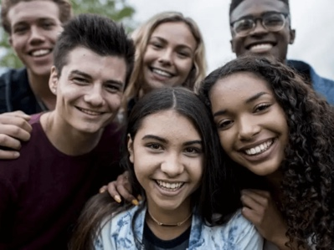  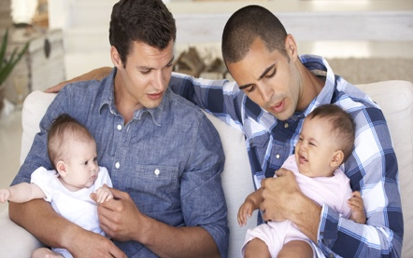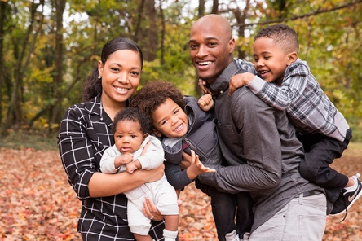  family  family
 | Vocabulary  - friends  - boy  - girl  - feelings  - similar  - different  - boy  - girl  - male  - female  - parts  - penis  - vulva | Human Life Cycle  