Year 6 Spring 1 RE – Sikhism
Key facts  - The langar is a common kitchen where food is served in a gurdwara. One is attached to every temple, and the food is served to all the visitors for free.  - At the langar, only vegetarian food is served. After a person eats at the langar they are not supposed to eat meat for the rest of the day.  - Guru Angad formalised langar, he also set the rules and training method for volunteers (sevadars) who operated the kitchen.  - Vand Chakna - sharing what one earns, generosity, the giving of charity. This is considered a religious duty because Sikhs believe this encourages compassion.  - Sewa - giving selfless service to the community. This should be practised in all areas of a Sikh's life.  - Daya to sympathize with, to have pity on others. It means ‘suffering in the suffering of all others.  - Part of Sikh virtues of truthful living (sat); means working to make all things fair, or to bring equality. | 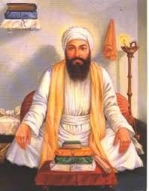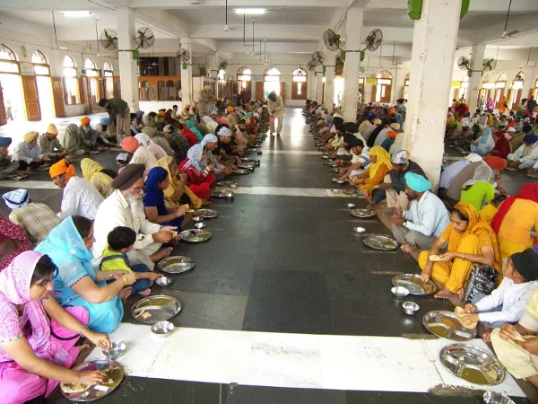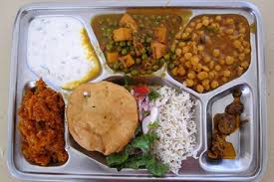  Guru Angad langar hall langar plate  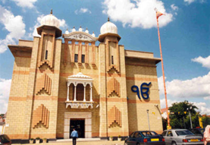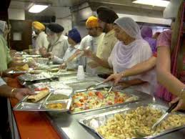  gurdwara servadars in the langar
 | Vocabulary  - gurdwara  - langar  - sevadars  - Vand Chakna  - Sewa  - Daya  - sangat  - compassion  - charity  - sympathize  - charity  - Sanskrit | 