Year 5 Spring 1 RE – Sikhism
Key facts  - There were 10 Sikh Gurus starting with Guru Nanak in 1469 and ending with Guru Gobind Singh in 1708.  - The word "Guru" is a Sanskrit word meaning teacher, honoured or religious person.  - Guru Nanak was the founder of Sikhism.  - Guru Angad developed the langar.  - Guru Amar Das made many social reforms to improve the status of women.  - Guru Ram Das established the city of Amritsar.  - Guru Arjun became the first Sikh martyr when he was executed on the orders of the Mughal Emperor.  - Guru Hargobind designed the Sikh flag.  - Guru Har Rai collected rare plants and used them to make medicines.  - Guru Har Krishan died serving victims of smallpox at the age of 8. | 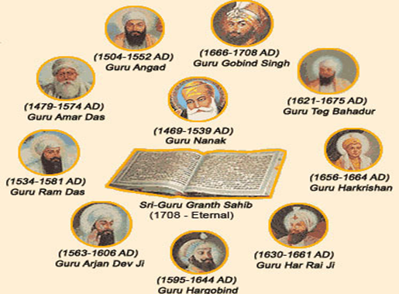  Sikh Gurus
 | Vocabulary  - Guru  - Sihk  - Gudwara  - Sanskrit  - langar  - Amritsar  - Martyr  - Mughal  - Kalsa  - Vaishakhi | Key facts  - Guru Tegh Bahadur led the first massive non-violent protest movement against the Mughal Emperor'  - Guru Gobind Singh created the Khalsa on the Vaisakhi of 1699.  - The Guru Granth Sahib is the scripture (holy book) of the Sikhs.  - The Guru Granth Sahib is kept in a Gudwara and the centre piece is the Takht

