Year 5 Computing Knowledge Organiser: Unit 5.6 – 3D Modelling
Key Images | Key Learning
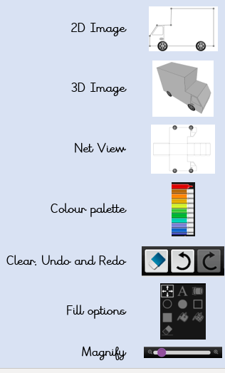 | - To be introduced to 2Design and Make and the skills of computer aided design.  - To explore the effect of moving points when designing.  - To understand designing for a purpose.  - To understand printing and making.
 | Key Vocabulary | Key Questions
 | - CAD – Computer aided Design  - Modelling  - 3D  - Viewpoint  - Polygon  - 2D  - Net  - 3D Printing  - Points  - Template | What are the different view of an object available in 2Design and Make?  Net, Points and 3D.  How can the objects designed in 2Design and Make be turned into 3D objects?  You can print the net and then cut and fold this into shape or you can convert the file into a format recognised by 3D printers.  How is CAD software used in industry?  It is used to design 3D objects in a 2D environment.  Some examples are; Architectural plans for buildings; designing layouts for interiors; designing objects such as packaging and designing mechanical components; designing shoes and clothing.
Reference to

