Year 4 Spring 1 RE – Sikhism
Key facts  - Hola Mohalla, also called Hola, is a three day long Sikh festival that takes place on the first day of the lunar month of Chet which usually falls in March.  - "Hola Mohalla" stands for "mock fight".  - Guru Gobind Singh, the tenth Sikh Guru built upon the story of Prahlad and founded the festival of Hola Mohalla.  - This festival is a time for Sikhs to practise their military exercises and hold mock battles.  - During this festival, processions are organised in the form of army type columns accompanied by war-drums and standard-bearers, who march from one gurdwara to another.  - During the 3 day festival many activities take place such as mock battles, exhibitions/displays of weapons, bareback horse-riding and various other feats of bravery. This is followed by kirtan, (music and poetry competitions). | 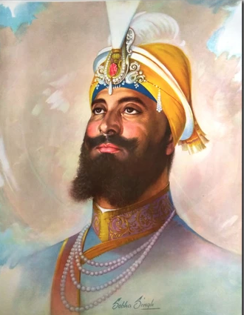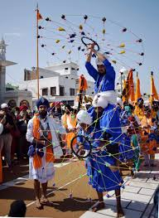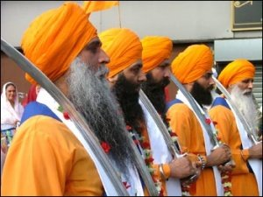  Guru Gobind Singh Hola Mohalla celebrations A column of Sikhs  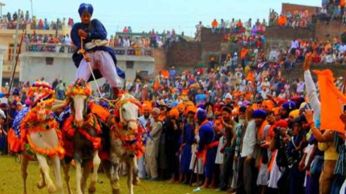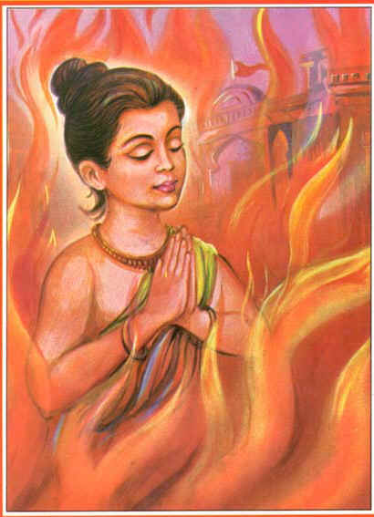  Bareback horse-riding Prahlad in the flames
 | Vocabulary  - gurdwara  - Hola Mohalla  - Prahlad  - Chet  - Guru Gobind Singh  - military  - Gatka  - kirtan, | The story of Prahlad gives Sikhs several moral instructions such as:  - God prevails everywhere.  - God will always save his devotees.  - Devotion can be practised at any point of time. Age does not matter.  - Constant faith in God leads to devotion.  - The people who are practising evil will be punished.

