Year 4 Computing Knowledge Organiser: Unit 4.6 – Animation
Key Images | Key Learning
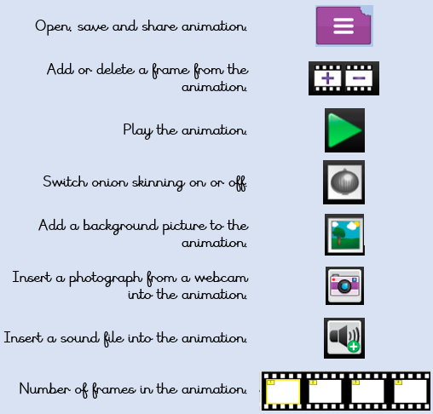 | - To discuss what makes a good animated film or cartoon.  - To learn how animations are created by hand.  - To find out how 2Animate can be created in a similar way using the computer.  - To learn about onion skinning in animation.  - To add backgrounds and sounds to animations.  - To be introduced to ‘stop motion’ animation.  - To share animation on the class display board and by blogging.
 | Key Vocabulary | Key Questions
 | - Animation  - Flipbook  - Frame  - Onion skinning  - Background  - Play  - Sound  - Stop motion  - Video clip | What is an animation?  Animation is the process of giving the illusion of movement to drawings, models, or inanimate objects. Animated motion pictures and television shows are highly popular forms of entertainment.  What is meant by onion skinning?  Onion skinning is a 2D computer graphics term for a technique used in creating animated cartoons and editing movies to see several frames at once.  What is meant by stop frame animation?  Stop motion animation is a filming technique in which objects (such as clay models) are photographed in a series of slightly different positions so that the objects seem to move.
Reference to

