Year 4 Computing Knowledge Organiser: Unit 4.5 – Logo
Key Images | Key Learning
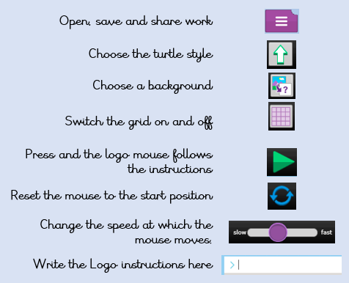 | - To learn the structure of the coding language of Logo.  - To input simple instructions in Logo.  - Using 2Logo to create letter shapes.  - To use the Repeat function in Logo to create shapes.  - To use and build procedures in Logo.
 | Key Vocabulary | Key Questions
 | - LOGO  - BK  - FD  - RT  - LT  - REPEAT  - SETPC  - SETPS  - PU  - PD | What is Logo?  Logo is a text-based coding language used to control an on-screen turtle to create mathematical patterns.
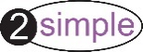
Reference to

