Year 3 Spring 1 RE – Sikhism
Key facts  - Ik Onkar, Ik means one. Onkar means supreme reality or being.  - Khanda is the main symbol of the Sikhism.  - Guru Gobind Singh founded the Khalsa. All men and women who belong to the Khalsa must wear five symbols which show they are Sikh. These are known as the five Ks.  - Kesh means hair. Sikhs make a promise to not cut their hair but let it grow as a symbol of their faith.  - Kangha is a small wooden comb. Sikhs use this to keep their hair in place and it is a symbol of cleanliness.  - The Kara is a steel bangle worn on the arm. It is a continuous circle and reminds Sikhs to behave well and follow their faith.  - Kachera are short trousers worn as underwear. They are a symbol of leaving old ideas behind and following new better ones.  - The Kirpan is a warrior sword, a very tiny one is worn as a symbol of dignity and self-respect. | 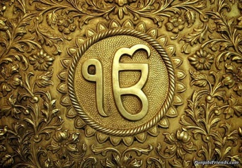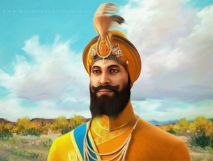  Ik Onkar Guru Gobind Singh Kesh  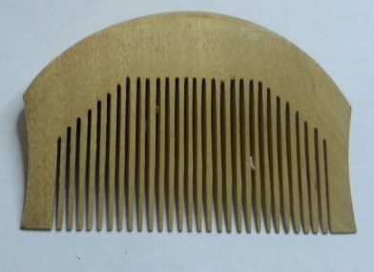 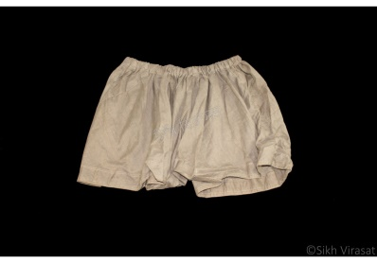 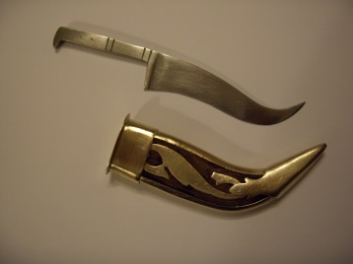 Kangha Kachera Kirpan
 | Vocabulary  - Ik Onkar  - Khanda  - Guru Gobind Singh  - Khalsa  - Kesh  - Kangha  - Kachera  - Kirpan | 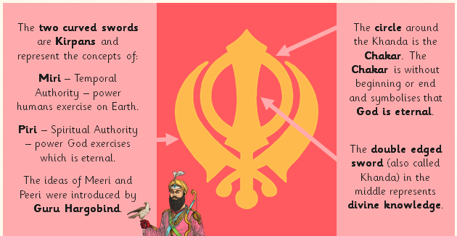  Khanda the main symbol of Sikhism

