Year 3 Spring 1 Design and Technology – Mechanisms Mechanical Posters
Key facts  - A mechanism is when two or more components act together to make an action take place  - A lever is a bar that moves at a point  - A pivot moves around in a circle, staying in one position.  - Linkage are composed of links and lower pairs  - The simplest closed-loop linkage is the four-bar linkage, which has three moving links, one fixed link and four pin joints.  - A linkage with one link fixed is a mechanism  - Making pictures and posters with moving parts makes them more interesting and appealing to look at | 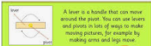  pivot  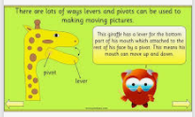  lever  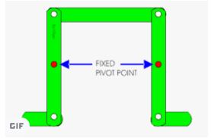  linkage
 | Vocabulary  - recycle  - mechanism  - mechanical system  - lever  - linkage  - pivot  - input  - output  - prototype | What you need to make a…  Pivot  - hole punch  - split pin  - card  Lever  - hole punch  - split pin  - card  - glue

