Year 3 Computing Knowledge Organiser: Unit 3.5 – Email
Key Images | Key Learning
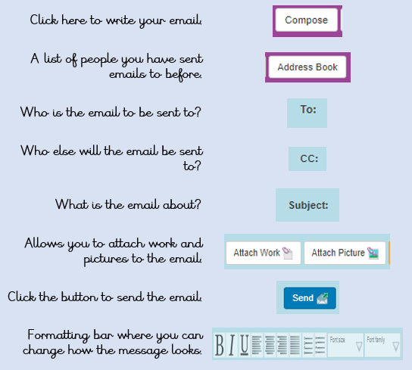 | - To think about different methods of communication.  - To open and respond to an email using an address book.  - To learn how to use email safely.  - To add an attachment to an email.  - To explore a simulated email scenario.
 | Key Vocabulary | Key Questions
 | - Communication  - Email  - Compose  - Send  - Report to the teacher  - Attachment  - Address book  - Save to draft  - Password  - CC  - Formatting | What is email?  Email is a method of sending electronic communication from one device to another.  What should I do if I receive an email that makes me upset or scared?  If you are at school, you should tell the teacher immediately. If you receive the message at home, then you should tell a parent or guardian.  What information can I send in an email?  As well as sending a message, files such as photographs, videos, music and other resources can be attached to the email and sent to the receiver.
Reference to

