Year 2 Spring 1 PSHCE –Resposible Citizens
Key facts  - We need to concentrate when crossing the road.  - We need to look and listen when we are crossing the road.  - Only cross the road when it is safe to do so.  - Lollipop people are sometimes there to help children cross the road safely. | lollipop person  pelican crossing  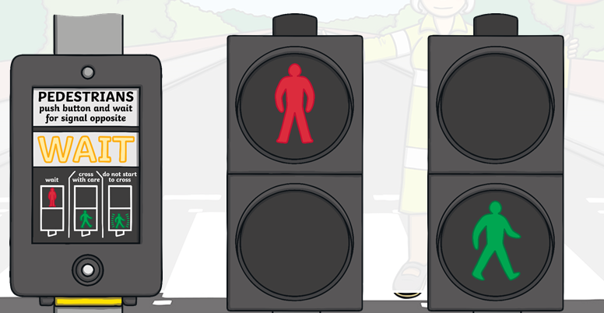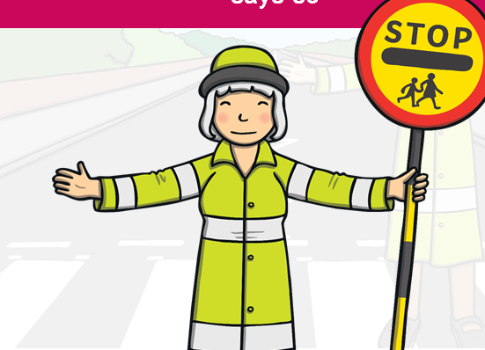  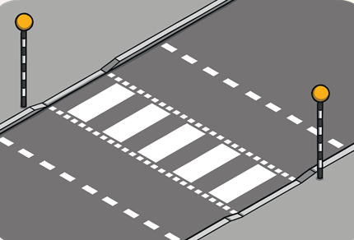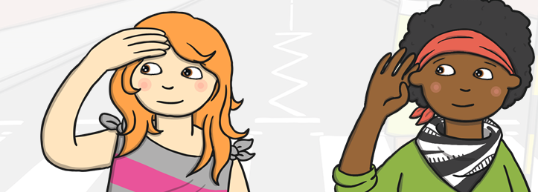  looking and listening  zebra crossing
 | Vocabulary  road  traffic lights  zebra crossing  lollipop person  risk  danger  signs  safe | 