Year 2 Spring 1 Humanities – India
Key facts  - A physical feature is something that is naturally created.  - A human feature is something that is built by humans.  - The Earth has 7 continents- Asia, Africa, North America, South America, Antarctica, Europe and Australia.  - The Earth has 5 oceans -  Atlantic, Indian, Pacific, Southern and Arctic ocean.  - India is the second most populated country in the world after China.  - India is home to 1.3 billion people.  - Taj Mahal is one of the wonders of the world.  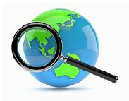  - Mount Everest is Earth's highest mountain located in the Himalayas, north of India. | 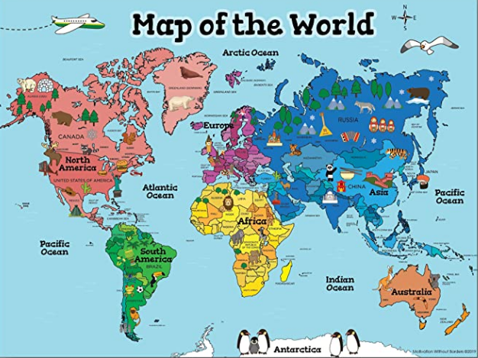  Mumbai  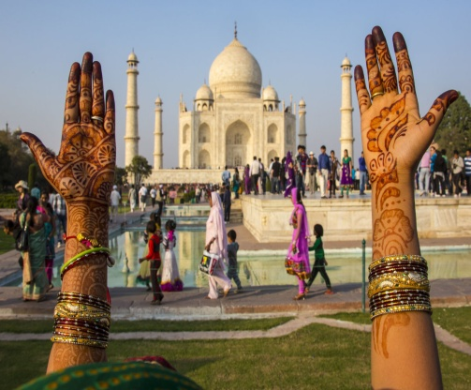  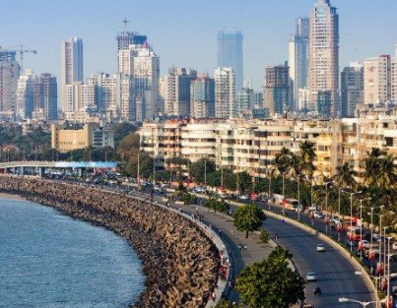  Taj Mahal
 | Vocabulary  - India / Mumbai  - Continent/ocean  - country/village  - Asia / Europe  - Himalayas  - New Delhi  - London/city  - River Ganges  - River Thames | Map  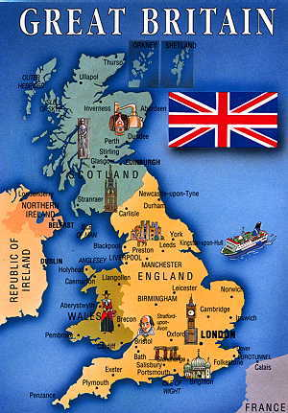  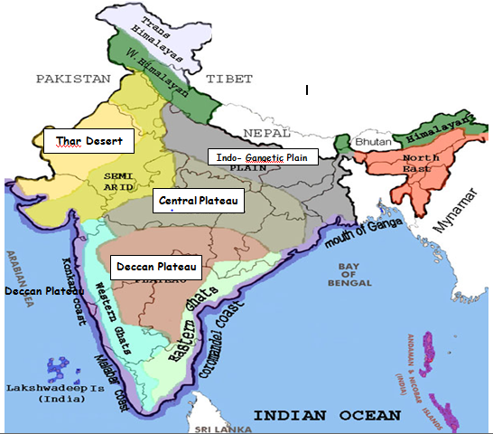  India United Kingdom

