Year 2 Spring 1 Design and Technology – Fabric Faces
Key facts  - A fabric is a woven or knitted material  - It is made from thread or yarn  - Yarn is made by spinning wool, flax, cotton or other materials into long strands  - Traditionally these were spun on a spinning wheel. But now days they are created on a machine  - Fabrics are formed by weaving, pressing strands together, crocheting, knitting, and knotting  - Cotton grows on a plant. It is planted in April and harvested in the autumn | 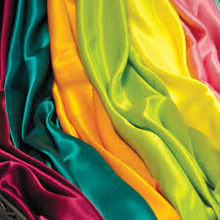  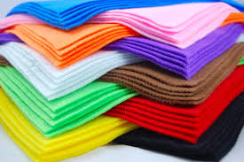  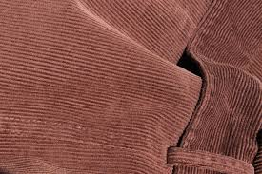  felt  corduroy  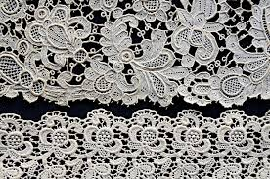  silk  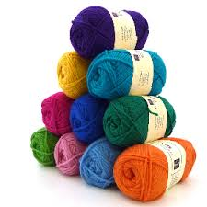  cotton  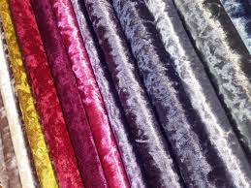  lace  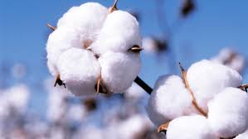  wool  velvet
 | Vocabulary  - fabric  - textile  - join  - attach  - design criteria  - evaluate  - attach  - template  - tools | Ways to join fabrics  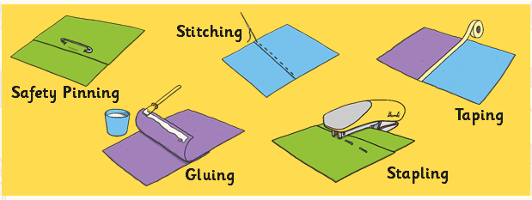  Fabric can be joined together in different ways, using different things. Your choice of joining method depends on lots of different things; such as how strong the join needs to be, or what the material is. It should be thought about very carefully.

