Year 2 Computing Knowledge Organiser: Unit 2.6 – Creating Pictures
Key Images | Key Learning
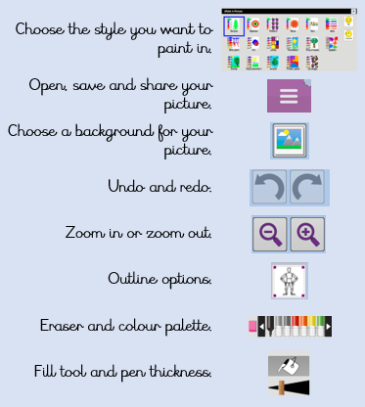 | - To learn the functions of the 2Paint a Picture tool.  - To learn about and recreate the Impressionist style of art (Monet, Degas, Renoir).  - To recreate Pointillist art and look at the work of pointillist artists such as Seurat.  - To learn about the work of Piet Mondrian and recreate the style using the lines template.  - To learn about the work of William Morris and recreate the style using the patterns template.
 | Key Vocabulary | Key Questions
 | - Impressionism  - Palette  - Pointillism  - Share  - Surrealism  - Template | What are the main features of Impressionism?  Impressionism is a style of painting that focuses on the effects of light and atmosphere on colours and forms. Impressionist artists often used broken brush strokes.  What are the main features of Pointillism?  Pointillism is a painting technique developed by the artist George Seurat. It involves using small, painted dots to create areas of colour that together form a pattern or picture.  What are the main features of Surrealism?  Surrealistic art is characterized by dream-like visuals, the use of symbolism and collage images. Several prominent artists came from this movement, including Renee Magritte, Salvador Dali, and Max Ernst.
Reference to

