Year 1 Spring 1 Design and Technology – Moving Pictures
Key facts  - A mechanism is when two or more components act together to make an action take place  - A slider moves up and down, or left to right along a single track or line  - A pivot moves around in a circle, staying in one position.  - A lever is a bar that moves at a point  - A book or story with a moving picture allows for the reader to interact on another level with the book  - Traditional Tales are very good for creating moving images – the Gingerbread Man running, Jack climbing the beanstalk or Little Red Riding Hood walking through the woods | 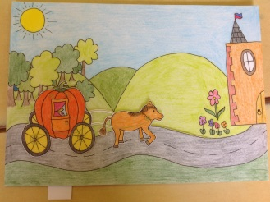  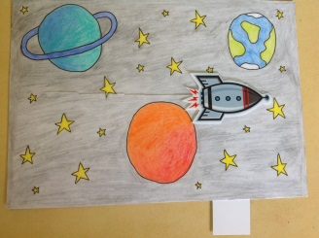  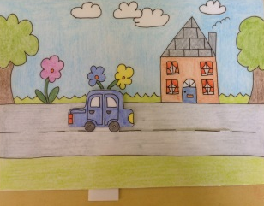  pivot  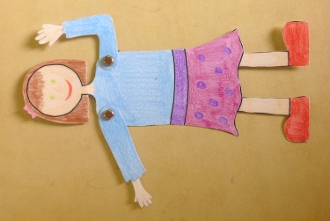  slider  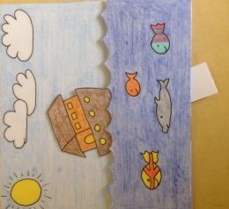  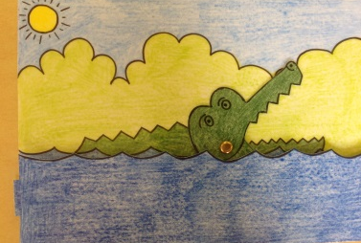  lever and pivot
 | Vocabulary  - slider  - pivot  - lever  - mechanism  - push  - pull  - turn  - rotate  - direction | What you need to make a…  Pivot  - hole punch  - split pin  - card  Slider  - scissors  - card  - glue  Lever  - hole punch  - split pin  - card  - glue

