Year 1 Computing Knowledge Organiser: Unit 1.5 – Maze Explorers
Key Images | Key Learning
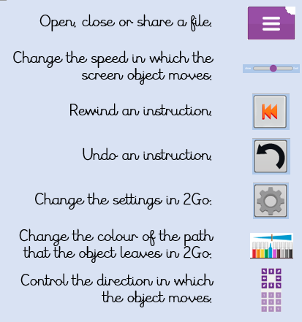 | - To understand the functionality of the direction keys.  - To understand how to create and debug a set of instructions (algorithm).  - To use the additional direction keys as part of an algorithm.  - To understand how to change and extend the algorithm list.  - To create a longer algorithm for an activity.  - To set challenges for peers.  - To access peer challenges set by the teacher as 2dos.
 | Key Vocabulary | Key Questions
 | - Direction  - Challenge  - Arrow  - Undo  - Rewind  - Forward  - Backwards  - Right turn  - Left turn  - Debug  - Instruction  - Algorithm | What is 2Go?  2Go is a program that allows you to move an object around the screen using either the arrows or by creating a simple sequence of instructions.  How do I undo a mistake on 2Go?  In 2Go you can either click on the undo button to go back one step or the rewind button to go back to the start of the challenge.

Reference to

