Year 6 Autu,mn 1 RE – Hinduism
Key facts H  - Pilgrimage in Hinduism, as in other religions, is the practice of journeying to sites where religious powers, knowledge, or experience are deemed especially accessible.  - There are many different places for Hindus to go on pilgrimage. Rivers, mountains and temples linked to different gods and goddesses are all popular places to visit.  - Hindus try to do at least one pilgrimage in their lifetime.  - The Kumbh Mela (the "pitcher festival") is one of the holiest of Hindu pilgrimages that is held four times every twelve years; the location is rotated among the four cities of Prayagraj, Haridwar, Nashik, and Ujjain.  - The most famous Hindu pilgrimage is the Kumbh Mela, which takes place at the River Ganges in India.  - Up to 40 million people come to purify themselves in the water, the biggest gathering of people on Earth  - The Char Dham ("four abodes") is a set of four pilgrimage sites in India. Hindus believe that visiting these sites helps achieve moksha (salvation).  - Mahamaham, is a Hindu festival celebrated every 12 years in the Mahamaham tank located in the South Indian town of Kumbakonam in Tamil Nadu, India. | 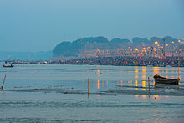  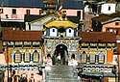  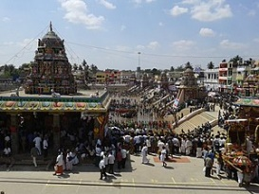  Char Dham  Mahamaham  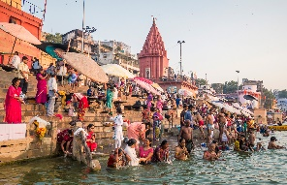  Prayag  Kumbh Mela  The Ganges
 | Vocabulary  - dharma  - reincarnation  - moksha  - samsara  - karma  - pilgrimage  - Ganges  - Kumbh Mela | The Ganges  Some Hindus believe that the river Ganges flowed from Heaven with the aim of purifying humans. The Hindu scriptures mention the river Ganges and it is referred to as Mother Ganges. Many stories in Hindu scripture feature the river, and Lord Vishnu is said to have spent time at the Ganges.

