Year 5 Computing Knowledge Organiser: Unit 5.2 – Online Safety
Key Images | Key Learning
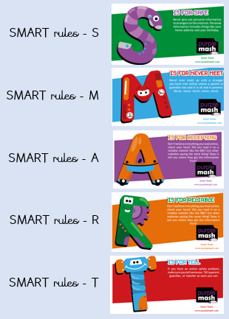 | - To gain a greater understanding of the impact that sharing digital content can have.  - To review sources of support when using technology and children’s responsibility to one another in their online behaviour.  - To know how to maintain secure passwords.  - To understand the advantages, disadvantages, permissions and purposes of altering an image digitally and the reasons for this.  - To be aware of appropriate and inappropriate text, photographs and videos and the impact of sharing these online.  - To learn about how to reference sources in their work  - To search the Internet with a consideration for the reliability of the results of sources to check validity and understand the impact of incorrect information.
 | Key Vocabulary | Key Questions
 | - online safety  - smart rules  - password  - reputable  - encryption  - identity theft  - shared image  - plagiarism  - citations  - reference  - bibliography | Who do I tell if I see anything online that makes me upset or scared?  When you are at school you should tell the teacher or another adult. At home you should tell your parent or guardian or another adult that you trust.  Why are passwords so important?  Passwords protect your information and stop other people accessing it. Passwords are like a toothbrush; they should not be shared with anyone else.  Why is it important to reference sources in my work?  If you use a book or article written by someone else, then you must reference it, so people know where you got the information from. If you don’t do this then it is known as plagiarism.

